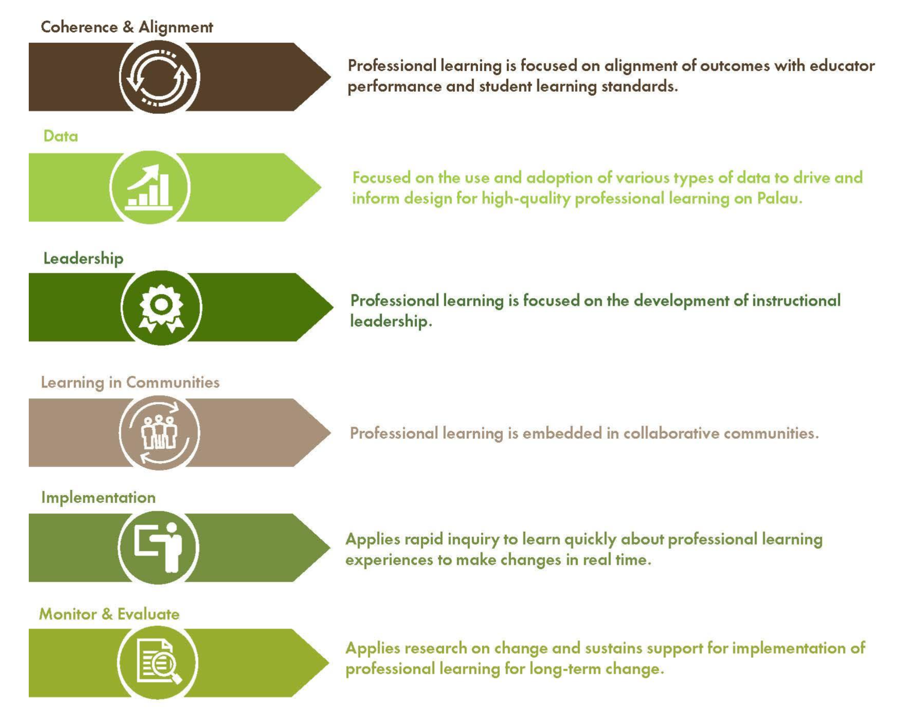
Instructional Coaching
Connects teacher expectations and actions with student learning standards and outcomes
Uses teacher and student data to inform reflection and planning
Develops principal and specialist leadership skills
Fosters job-embedded, collaborative learning
Includes weekly debrief opportunities to check in, clarify and celebrate progress
Developing internal capacities to self-train after the grant has ended

